More than half a million asylum applications lodged in the EU+ so far in 2019

* 19TH NOVEMBER 2019

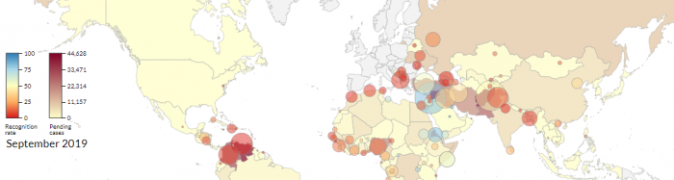

***Per capita applications indicate high pressure on smaller EU+ countries.***

**More than half a million (515 825) asylum applications have been lodged in the EU+ during the first nine months of 2019**, up by 10% compared to the same period a year ago.

The proportion of applications receiving a positive decision (known as **"recognition rate"**) so far this year was 34%, compared to 33% in the first nine months of 2018.

Most applications were lodged by nationals of Syria, Afghanistan and Venezuela. These three citizenships continued to account for a quarter of all asylum applications in the EU+. For the sixth consecutive month, Afghan applications outnumbered Venezuelan, and peaked in September, when more applications were lodged (> 5 600) than in any month since December 2016.

Data suggest that, so far in 2019, EU+ countries characterised by lower population size were under particularly high pressure. For example, in July the most applications per capita (relative to the countries’ population size) were lodged in **Cyprus** and **Malta**, followed by **Greece**, **Sweden** and **Luxembourg**. As of the spring of 2019, Cyprus had been receiving, on average, about 1 500 applications per million inhabitants each month, more than twice as many as Malta (close to 700) and about three times as many as Greece (over 450).

At the end of September, there were some **507 800 applications awaiting a decision in first instance in the EU+**. In addition, an estimated 381 700 applications were awaiting a decision at the appeal or review stage at the end of July 2019, amounting to some 890 000 cases pending at all instances overall. This means that currently the pressure is higher on first-instance authorities. One in four pending applications pertained either to Syrian, Afghan or Venezuelan nationals.

For more information and an interactive data visualisation, please visit the [Latest Asylum Trends](https://www.easo.europa.eu/latest-asylum-trends) page.